A Plea from the Minnesota Floral Community

March 26, 2020 Governor Walz,

As a Minnesota Florist, I am requesting that you remove Minnesota florists (Industry Code 4531) from the non-essential list of Emergency Executive Order 20-20. Our businesses are essentially Local Delivery (Industry Code 4922) classified as essential in EO 20-20. Alternatively, please grant an exception to allow florists to continue online sales, floral delivery and curbside pickup.

We have much in common with restaurants, online businesses and delivery services which are allowed to make, sell and deliver and provide curbside pickups of their products - Pizza Hut, UPS, FedEx and Amazon, as examples. The majority of our business is transacted over the telephone and internet - and currently all of our orders come in that way. One can call or email an order to a national floral internet company and receive delivery by UPS. We are local businesses that operate the same way yet EO 20-20 prohibits us from doing so.

Florists, like other businesses allowed to operate can have very little physical interaction with the public by taking phone and internet orders and make "no touch" deliveries and curbside pickup.

Fresh flowers and plants are a great morale booster and spread happiness especially during this very challenging and unsettling time. Minnesota greenhouses are full of Easter plants and flowers. Why not help everyone to be able to continue growing their product and getting them delivered to people that still want to celebrate Easter?

Please support my request by deeming Minnesota Florists as essential or at a minimum grant an exception to EO 20-20 by allowing florists to continue floral delivery and curbside pickup.

Respectfully yours,

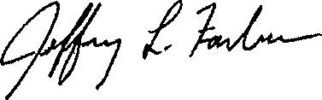

President Greenwood Nursery Tracy, MN 56175