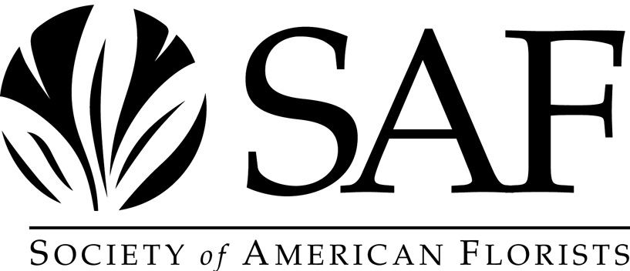

Alex Laurie Award for Research and Education
Nomination Packet and Information

Thanks for your time and effort in helping SAF recognize those individuals who have made significant contributions to the health and advancement of the floriculture industry through research and education. Enclosed are all of the materials you need to submit a nomination for the Alex Laurie Award for Research and Education. Please follow the instructions below.

1. Deadline for receipt of nominations by SAF is May 1, 2024.

2. Please complete all sections of both pages of the nomination form.

3. If you need additional space, please continue on additional sheets, clearly referencing the nomination form section to which your additional comments are related.

4. You may approximate the enclosed form with your own document provided that it contains all information requested, preferably in the same order and with the same titles/subtitles.

5. Please include a summary, not to exceed one page, of relevant publications by the nominee. Summary should include citations for what the nominator deems to be the nominee’s five top publications and statements about why they are important, followed by a simple tabulation of other publications.

6. A letter of introduction from the nominator may be included if so desired.

7. Complete nomination must be no longer than five pages, minimum type size 10 point, including letter of introduction, completed nomination forms (2 pages), summary of publications and any additional sheets as described in item 3 above.

8. In addition to the five pages, an unlimited number of letters of recommendation or support from other parties may be submitted. Such letters may be collected by the nominator and submitted with the nomination forms or may be forwarded directly to SAF at the address below by the authors of such letters.

Please submit all nomination materials:
Stephanie Brady, Awards Committee Liaison
Society of American Florists
1001 N. Fairfax Street, Suite 201

Alexandria, VA 22314
sbrady@safnow.org

If you have questions, contact Stephanie Brady at (703) 838-5230 or sbrady@safnow.org

A brief biography of Professor Alex Laurie
________________________________________________

SAF’s Alex Laurie Award for Research and Education is presented annually to an individual who has made broad-scope, long lasting contributions to research or education in the floriculture industry.

The award is named for Alex Laurie who, throughout a career that spanned more than 60 years, laid the groundwork for research that revolutionized the floriculture industry and who left a lineage of students, teachers and researchers who continued to this day to provide the information necessary to ensure the industry’s future. Professor Laurie exemplified the perfect blend of researcher and educator – he knew the value of his research results, knew how to communicate that value and knew how to teach growers to apply it to their own operations. His pioneering work in photoperiodism, fertilizers, nutrition and other areas paved the way for additional research leading to countless advancements in floriculture production.

Laurie was born in France in 1892, and arrived in the United Stated in 1903, attending high school in New York City. He received his BS degree from Cornell University in 1914 and was for two years a horticulture instructor at the University of Maine. In 1916, Laurie became a horticulturist at the Missouri Botanical Garden in St. Louis, receiving his MA from St. Louis’ Washington University in 1917. He remained at the Botanical Garden until 1920, and from 1920 to 1925 worked in various aspects of the commercial floriculture industry, including retail floristry and greenhouse production.

In 1925, Laurie became Assistant Professor of Horticulture at Michigan State University, where he remained until 1929. During that time, he helped organize and served as Executive Secretary of the Michigan Florists Association.

In 1929, Laurie became Head Professor of the Division of Floriculture and Ornamental Horticulture at the Ohio State University, where he remained until he retired from teaching in 1952. During this tenure at OSU, over 600 students received degrees in Floriculture and Ornamental Horticulture under his tutelage. Many of these students went on to highly responsible positions in industry, education, and research, and now third generations of his students are teaching a fourth. While at OSU, Laurie helped found and served as Executive Secretary-Treasurer of Roses, Inc.

In 1952, Laurie retired to Florida, where he founded and was president of Whistling Pines Gardens Inc., a tropical plant production nursery. In 1963, he moved to Pine Mountain Georgia, and became a horticultural consultant to Callaway Gardens. Mr. Laurie died in 1982 at the age of 89.

In addition to those he helped found, Laurie was a member of fifteen other floriculture industry associations, and in 1964 was elected to SAF’s Floricultural Hall of Fame. In 1977, he received the SAF award named for him. He was the author of eight books on floriculture production, nursery management and retail floristry, and was author and co-author of dozens of papers published in the scientific literature and articles published in the trade and popular press.

Alex Laurie Award for Research and Education
Nomination Packet and Information

USE ADDITIONAL SHEETS AS NECESSARY

I. Nominee Information Date Submitted: ______________

Name: ________________________________________________________________________
Company/Institution ________________________________________________________________________
Business Address ________________________________________________________________________
City/State/Zip ________________________________________________________________________
Telephone/Fax/E-mail ________________________________________________________________________
Home Address ________________________________________________________________________
City/State/Zip ________________________________________________________________________
Telephone/Fax ________________________________________________________________________
Date of Birth ________________________________________________________________________

II. Education

Academic Education (post-high school)
Institution Degree/Curriculum Date(s)

_____________________________ __________________________________ ____________________
_____________________________ __________________________________ ____________________
_____________________________ __________________________________ ____________________

Other Formal Education/Training

___________________________________________________________________________________________
___________________________________________________________________________________________
___________________________________________________________________________________________

III. Professional Experience/Industry Activities

Professional Experience/Career Activities in Floriculture Industry
Description Date(s)

___________________________________________________________________ ____________________
___________________________________________________________________ ____________________
___________________________________________________________________ ____________________
___________________________________________________________________ ____________________

Professional Experience/Career Activities Outside of Floriculture Industry
Description Date(s)

___________________________________________________________________ ____________________
___________________________________________________________________ ____________________
___________________________________________________________________ ____________________
___________________________________________________________________ ____________________

Membership/Participation/Leadership in Floriculture Industry Organizations
Organization Date(s)

___________________________________________________________________ ____________________
___________________________________________________________________ ____________________
___________________________________________________________________ ____________________
___________________________________________________________________ ____________________

Honors/Awards (Professional and Industry)
Organization Date(s)

___________________________________________________________________ ____________________
___________________________________________________________________ ____________________
___________________________________________________________________ ____________________
___________________________________________________________________ ____________________

IV. Testimonial
Please provide your personal viewpoint on the nominee’s contribution to the lasting improvement
of the floriculture industry through research and/or education.

___________________________________________________________________________________
__________________________________________________________________________________
__________________________________________________________________________________
__________________________________________________________________________________
__________________________________________________________________________________
__________________________________________________________________________________
__________________________________________________________________________________
__________________________________________________________________________________
__________________________________________________________________________________
__________________________________________________________________________________
__________________________________________________________________________________
__________________________________________________________________________________

V. Nominator Information

Name: __________________________________________________________

Company/Institution: __________________________________________________________

Business Address: __________________________________________________________

City/State/Zip: __________________________________________________________

Telephone/Fax/E-Mail: __________________________________________________________

Signature/Date: __________________________________________________________

